

ASSET VERIFICATION AND RECORDING TOOL KIT


Plot 31, Bukoto Street
P.O Box 7657, Kampala, Uganda
+256 (0) 39 2000216/0772525235
email: cpa@cpa.ug

www.cpa.com

August to September 2026

VERIFICATION DETAILS

NAME OF THE REGION: | WESTERN
SUB-REGION: | TOORO
Name of Local Government | KYENJONJO
VERIFIER PARTICULARS
Full name | JALIYAH BALUUBU
Contact/ email and Telephone | Jaliahb45@gmail.com  0794775877
Supervisor/ Sub team leader
Name | Prof: MBONIGABA DEPAUL
Contact | 0788483159
Date of submission | 06/09/2026

HEALTH CENTRES
INFORMANT INTERVIEW/DISCUSSION GUIDE (INCHARGE OR RESPONSIBLE PERSON)

Name of Health Centre: KIGOYERA HEALTH CENTRE III

1a | Does the Facility have a record of all assets provided under UgIFT.  (Obtain a record and verify if it has the costs and numbers supplied | yes
1b | If Not ask how many were supplied and when.

2 | How does this facility Maintain (repair/service/replace) the assets provided under Ugift

The facility has a dedicated budget for repairs/replacements through its professional contacts and the incharge sometimes pays privately.

3 | Does the facility take regular record about functionality/ or breakdown of the assets provided? | YES

The facility provided a register of all items that were delivered although most of them were still in storage due to lack of enough staff and knowledge on how to operate them

4 | How has the UgIFT support helped in service delivery in the area, any issues, challenges and any recommendations for better program implementation.

The incharge expressed gratitude to the UGIFT program for reaching out to provide the most crucial equipment that has helped the health workers to perform their duties diligently.

The incharge said that the program should offer training sessions on how to use the assets so as to facilitate the full usage of the assets.

The incharge said that the assets provided health workers lack knowledge on how to use them.

PROCEED TO VERIFICATION AFTER THIS DISCUSSION

Health centre checklist

NAME OF LG KYENJONJO
NAME OF HEALTH FACILITY KIGOYERA HEALTH CENTER III

Equipment/ Item | Department | Asset Number | Item  Description | Life in Months | Tag Number ( engrave no.) | Date Of Purchase | Date Placed In Service | Recoverable cost | Cost | Acc Dep Cost | Net Book Value | Ytd Deprn | Equipment status | Remarks
B.P. Machine, Digital | Health |  | White in color with a screen and a plastic frame |  | Not engraved |  | 13,10.21 |  |  |  |  |  | Functional | In use
 | Health |  | White in color with a screen and a plastic frame |  | Not engraved |  | 13.10.21 |  |  |  |  |  | Functional | In use
B.P. Machine (Aneroid wall mounted) | Health |  | Navy blue, has a bulb and tubing, has a black pulse rate connected on an arm cuff on a holder |  | Not engraved |  | 13.10.21 |  |  |  |  |  | Functional | In use
 | Health |  | Navy blue, has a bulb and tubing. |  | Not engraved |  | 13,10.21 |  |  |  |  |  | Functional | In use
Autoclave 20 Liters.,Duo Operated | Health |  | Cylindrical drum made of stainless steel with a heavy cover with black pressure valves. MS-151 |  | engraved |  | 17.10.21 |  |  |  |  |  | Functional | Manually in use
 | Health |  | Cylindrical drum made of stainless with a heavy cover with black pressure valves |  | engraved |  | 17.10.21 |  |  |  |  |  | Not functional and still in store | Not in use due to electricity issues.
Auto clave charcoal | Health |  | A non electric fired pressure steam sterilizer |  | Not engraved |  |  |  |  |  |  |  | Functional | In use
Bowl, Kick
Bowl Stand | Health |  | A double bowl stainless steel device |  | Not engraved |  | 13.10.21 |  |  |  |  |  | Functional | In use
 | Health |  | A double bowl stainless steel device |  | Not engraved |  | 13.10.21 |  |  |  |  |  | Functional | In use
Cupboard Steel, Lockable | Health |  | 1 rectangular gray double door storage cabinet locking steel handles and shelves inside |  | KDG/HCIII/002 |  | 13.10.21 |  |  |  |  |  | Functional | In use
 | Health |  | 1 rectangular gray double door storage cabinet, locking steel handles and shelves inside |  | KDG/HCIII/001 |  | 13.10.21 |  |  |  |  |  | Functional | In use
Drip Stand | Health |  | A medical device used to hold and support bottles or bags of fluids, medication, blood products during patient care |  |  |  | 13.10.21 |  |  |  |  |  | Functional | In use
 | Health |  | A medical device used to hold and support bottles or bags of fluids. |  | Not engraved |  | 13.10.21 |  |  |  |  |  | Functional | In use
 | Health |  | A medical device used to hold and support bottles or bags of fluids |  | Not engraved |  | 13.10.21 |  |  |  |  |  | Functional | In use
 | Health |  | A medical device used to hold bags of fluids. |  | Not engraved |  | 13.10.21 |  |  |  |  |  | Functional | In use
 | Health |  | A medical tool used to hold and support bags and bottles of fluids |  | Not engraved |  | 13.10.21 |  |  |  |  |  | Functional | In use
 | Health |  | A medical tool used to hold and support bags and bottles of fluids |  | Not engraved |  | 13.10.21 |  |  |  |  |  | Functional | In use
 | Health |  | A medical tool used to hold and support bags and bottles of fluids |  | Not engraved |  | 13.10.21 |  |  |  |  |  | Functional | In use
ESR Stand | Health |  | A tool used to hold blood collection tubes completely vertical during a sed rate test |  | Not engraved |  | 13.10.21 |  |  |  |  |  | Not yet functional | Still in store
Examination Couch | Health |  | 1 black padded bed with a stainless steel stands which is raisable |  | Not engraved |  | 13.10.21 |  |  |  |  |  | Functional | In use
 | Health |  | 1 black padded bed with stainless steel stand and raisable |  | Not engraved |  | 13.10.21 |  |  |  |  |  | Functional | In use
 | Health |  | 1 black padded bed with stainless steel stand and raisable |  | Not engraved |  | 13.10.21 |  |  |  |  |  | Functional | In use
Examination light,LED | Health |  | 1 specialized medical light that provides bright, focused and cool illumination for patient check up and minor surgeries. KS-Q6 |  | Not engraved |  | 13.10.21 |  |  |  |  |  | Functional | In use
 | Health |  | 1 specialized medical light that provides bright, focused and cool illumination for patient check up and minor procedures. KS-Q6 |  | Not engraved |  | 13.10.21 |  |  |  |  |  | Functional | In use
 | Health |  | 1 specialized medical light that provides bright, focused and cool illumination for patient check up and minor surgeries. KS-Q6 |  | Not engraved |  | 13.10.21 |  |  |  |  |  | Functional | In use
Glucometer | Health |  | Hand held electronic device with a small screen, a slot where you insert a test trip and button for control |  | Not engraved |  | 22.06.21 |  |  |  |  |  | functional but not operating | Still in store
 | Health |  | Hand held electronic device with a small screen where you insert a test trip and button for control |  | Not engraved |  | 22.06.21 |  |  |  |  |  | functional but not operating | Still in store
Haemoglobin Meter, Digital | Health |  | 1 small portable electronic device used to measure the concentration of haemoglobin | 24.04.22 | Not engraved |  | 13.10.21 |  |  |  |  |  | Not yet functional | Still in store
 | Health |  | 1 small portable electronic device used to measure the concentration of haemoglobin | 24.04.22 | Not engraved |  | 13.10.21 |  |  |  |  |  | Not yet functional | Still in store
Height Meter | Health |  | 1 long ruler like height measuring board. |  | Not engraved |  | 13.10.21 |  |  |  |  |  | Functional | In use
Instrument Trolley | Health |  | Stainless steel instrument with two shelves |  | Not engraved |  | 13.10.21 |  |  |  |  |  | Functional | In use
 | Health |  | Stainless steel with two shelves |  | Not engraved |  | 13.10.21 |  |  |  |  |  | Functional | In use
 | Health |  | Stainless steel with two shelves |  | Not engraved |  | 13.10.21 |  |  |  |  |  | Functional | In use
Microscope Binocular | Health |  | 1 olympus microscope LE-052 |  | MOH-GF-NMCP-NF-M3-MISC-332 |  | 13.10.21 |  |  |  |  |  | Functional | In use
Otoscope
Patient Screen | Health |  | 1 patient blue with white stands F-35 |  | Not engraved |  | 20.07.23 |  |  |  |  |  | Functional | In use
 | Health |  | 1 patient blue with White stands F-35 |  | Not engraved |  | 20.07.23 |  |  |  |  |  | Functional | In use
 | Health |  | 1 patient blue with white stands F-35 |  | Not engraved |  | 20.07.2023 |  |  |  |  |  | Functional | In use
Patient Trolley | Health |  | Stainless steel stands padded with a black bed |  | Not engraved |  | 13.10.21 |  |  |  |  |  | Functional | In use
 | Health |  | Stainless steel stands padded with a black bed |  | Not engraved |  | 13.10.21 |  |  |  |  |  | Functional | In use
Refrigerator, Basic | Health |  | One cream like refrigerator. LE-273 |  | Not engraved |  | 13.10.21 |  |  |  |  |  | Functional | In use
Stethoscope | Health |  | A stainless steel rod padded with a black cot used to listen to internal sounds of human |  | Not engraved |  | 13.10.21 |  |  |  |  |  | Functional | In use
 | Health |  | A stainless steel padded with a black rod used to listen to internal sounds |  | Not engraved |  | 13.10.21 |  |  |  |  |  | Functional | In use
 | Health |  | A stainless steel padded with a black cot used to listen to internal sounds |  | Not engraved |  | 13.10.21 |  |  |  |  |  | Functional | In use
 | Health |  | A stainless steel with a black padded rod used to listen to internal sounds |  | Not engraved |  | 13.10.21 |  |  |  |  |  | Functional | In use
Stop Watch | Health |  | One digital timer. LE-256 |  | Not engraved |  | 13.10.21 |  |  |  |  |  | Functional | Still in store
Stretcher | Health |  | I stainless steel with adjustable height. |  | Not engraved |  | 13.10.2021 |  |  |  |  |  | Functional | In use
Stove, Gas | Health |  | Stove gas |  | Not engraved |  | 13.10.21 |  |  |  |  |  | Functional | In use
 | Health |  | Stove gas |  | Not engraved |  | 13.10.21 |  |  |  |  |  | Functional | In use
Weighing Scale with Height Meter, Adult | Health |  | Heavy duty steel platform, aluminum height rod, rubber mat |  | Not engraved |  | 13.10.21 |  |  |  |  |  | Functional | In use
Weighing Scale, Infant | Health |  | Bowl/tray type battery operated scale |  | Not engraved |  | 13.10.2021 |  |  |  |  |  | Functional but not operational | In store
 | Health |  | Bowl/tray type battery operated scale |  | Not engraved |  | 13.10.2021 |  |  |  |  |  | Functional | In store
Weighing Scale, Toddler | Health |  |  |  |  |  | 13.10.2121 |  |  |  |  |  | Functional | In use
Wheel Chair | Health |  | 1 black wheel chair with stainless stands |  | Not engraved |  | 13.10.2021 |  |  |  |  |  | Functional | In good shape
 | Health |  | I black wheel chair with stainless steel stands |  | Not engraved |  | 13.10.2021 |  |  |  |  |  | Functional | In good shape
Audio Visual Equipment | Health |  | 1 audio visual tool that helps people learn by using both hearing and seeing at the same time. |  | Not engraved |  | 13.10.2021 |  |  |  |  |  | Functional but not operational | In store
Medical Waste Bin | Health |  | Plastic, brown and yellow with covers |  | Not engraved |  | 13.10.21 |  |  |  |  |  | Functional | In good shape and in use
 | Health |  | Plastic, brown and yellow with covers |  | Not engraved |  | 13.10.21 |  |  |  |  |  | Functional | In good shape and in use
 | Health |  | Plastic, brown and yellow with covers |  | Not engraved |  | 13.10.21 |  |  |  |  |  | Functional | In a good shape and in use
 | Health |  | Plastic, brown and yellow with covers |  | Not engraved |  | 13.10.21 |  |  |  |  |  | Functional | In a good shape and in use
 | Health |  | Plastic, brown and yellow with covers |  | Not engraved |  | 13.10.21 |  |  |  |  |  | Functional | In a good shape and in use
 | Health |  | Plastic, brown and yellow with covers |  | Not engraved |  | 13.10.21 |  |  |  |  |  | Functional | In a good shape and in use
Wall Clock | Health |  | A round clock operating on batteries |  | Not engraved |  | 13.10.21 |  |  |  |  |  | Functional | In use
 | Health |  | A round clock operating on batteries |  | Not engraved |  | 13.10.21 |  |  |  |  |  | Functional | In use
Diagnostic Equipment Set for MCH
Diagnostic Equipment Set for OPD | Health |  | I group of non-sterile instruments and devices in the OPD examination room |  | Not engraved |  | 13.10.2021 |  |  |  |  |  | functional | In good shape
 | Health |  | 1 group of non-sterile instruments and devices in the OPD examination room |  | Not engraved |  | 13.10.2021 |  |  |  |  |  | Functional | In good shape
Glassware Set, Laboratory, Basic | Health |  | A set of glass apparatus used in the laboratory. MIS-129 |  | Not engraved |  | 13.10.2021 |  |  |  |  |  | Functional but not yet operational | Still in store
 | Health |  | A set of glass apparatus used in the laboratory. MIS-129 |  | Not engraved |  | 13.10.2021 |  |  |  |  |  | Functional but not yet operational | Still in store
Hollow Ware Set, Treatment | Health |  | A set of stainless steel equipment. MIS-122 |  | Not engraved |  | 13.10.21 |  |  |  |  |  | Functional | In store
Instrument Set, Dressing | Health |  | Stainless steel containing all equipment |  | Not engraved |  | 13.10.2021 |  |  |  |  |  | Functional | In good shape
 | Health |  | Stainless steel containing all equipment |  | Not yet engraved |  | 13.10.2021 |  |  |  |  |  | functional | In good shape
Instrument Set, Basic ENT | Health |  | 1 set of stainless instrument, auto clavable stainless steel |  | Not engraved |  | 13.10.2021 |  |  |  |  |  | Functional | In good shape
Instrument Set, Suture | Health |  | 1 small set of ready packed sterilized instruments for stitching or surgical incision. MIS-125 |  | Not engraved |  | 13.10.2021 |  |  |  |  |  | Functional | In good shape
 | Health |  | 1 small set of ready packed sterilized instruments for stitching or surgical incision. MIS-125 |  | Not engraved |  | 13.10.2021 |  |  |  |  |  | Functional | In good shape
Pulse Oximeter, Hand held | Health |  | 1 small painless medical device that clips onto the finger to measure the amount of oxygen in blood |  | Not engraved |  | 13.10.21 |  |  |  |  |  | Functional | In use
 | Health |  | 1 small painless medical device that clips onto the finger to measure the amount of oxygen in blood |  | Not engraved |  | 13.10.21 |  |  |  |  |  | Functional | In use
Bed, Adult Patient with Mattress | Health |  | 1 pair of a metallic bed with a black padded mattress1 pair of a metallic bed with a black padded mattress |  | I |  | 13.10.2021 |  |  |  |  |  | Functional | In good shape and in use
 | Health |  | 1 pair of a metallic bed with a black padded mattress |  | Not engraved |  | 13.10.2021 |  |  |  |  |  | Functional | In good shape and in use.
 | Health |  | 1 pair of a metallic bed with a black padded mattress |  | Not engraved |  | 13.10.2021 |  |  |  |  |  | Functional | In good shape and in use
 | Health |  | 1 pair of a metallic bed with a black padded bed |  | Not engraved |  | 13.10.2021 |  |  |  |  |  | Functional | In good shape and in use
 | Health |  | 1 pair of a metallic bed with a black padded mattress |  | Not engraved |  | 13.10.2021 |  |  |  |  |  | Functional | In good shape
 | Health |  | 1 pair of a metallic bed with a black padded mattress |  | Not engraved |  | 13.10.2021 |  |  |  |  |  | Functional | In good shape
 | Health |  | 1 pair of a metallic bed with a black padded mattress |  | Not engraved |  | 13.10.2021 |  |  |  |  |  | Functional | In good shape
 | Health |  | 1 pair of a metallic bed with a black padded mattress |  | Not engraved |  | 13.10.2021 |  |  |  |  |  | Functional | Already in use
 | Health |  | 1 pair of a metallic bed with a black padded mattress |  | Not engraved |  | 13.10.2021 |  |  |  |  |  | Functional | Already in use
 | Health |  | 1 pair of a metallic bed with a black padded mattress |  | Not engraved |  | 13.10.2021 |  |  |  |  |  | Functional | Already in use
Bed, Pediatric Patient, With Mattress | Health |  | Black mattress side rails, pink and blue, gray with a drip stand |  | Not engraved |  | 13.10.2021 |  |  |  |  |  | Functional | In good shape
 | Health |  | Black mattress, side rails pink and blue, grey with a drip stand |  | Not engraved |  | 13.10.2021 |  |  |  |  |  | Functional | In good shape
 | Health |  | Black mattress side rails pink, blue, gray with a drip stand |  | Not engraved |  | 13.10.2021 |  |  |  |  |  | Functional | In good shape
 | Health |  | Black matress side rails pink, blue, gray with a drip stand |  | Not engraved |  | 13.10.2021 |  |  |  |  |  | Functional | In good shape
 | Health |  | Black mattress side rails pink, blue, gray with a drip stand |  | Not engraved |  | 13.10.2021 |  |  |  |  |  | Functional | In good shape
Bedside Locker | Health |  | A compact multi compartment storage cabinet placed next to a bed |  | Not engraved |  | 13.10.21 |  |  |  |  |  | Functional | Needs re-varnishing
 | Health |  | A compact multi compartment storage cabinet placed next to the bed |  | Not engraved |  | 13.10.21 |  |  |  |  |  | Functional | Needs re-varnishing
Cupboard, Instrument | Health |  | 1 Gray steel with shelves inside |  | Not engraved |  | 13.10.2021 |  |  |  |  |  | Functional | In use and good shape
 | Health |  | 1 gray steel with shelves inside |  | Not engraved |  | 13.10.2021 |  |  |  |  |  | Functional | In use and in good shape
Delivery Bed, Hydraulic Manual | Health |  | I blue padded surface, washable delivery hydraulic bed. MT 400 |  | Not engraved |  | 13.10.2021 |  |  |  |  |  | Functional | In good shape and in use
Oxygen Therapy Apparatus, Mininum 45L cylinder | Health |  | Oxygen gas cylinder |  | Not engraved |  | 13.10.21 |  |  |  |  |  | Functional | In use
 | Health |  | Oxygen gas cylinder |  | Not engraved |  | 13.10.21 |  |  |  |  |  | Functional | In use
Resuscitator Manual, Infant, with all Mask sizes
Resuscitator Manual, Adult, with all mask sizes
Suction Apparatus, (Electric) | Health |  | A medical device with two jars, suction tubing, foot pedal |  | KGD/HCIII/002 |  | 13.10.21 |  |  |  |  |  | Functional | In good shape
Suction catheters | Health |  | A thin flexible tube used to clear mucus, blood, and fluids from a patient’s airway |  | Not engraved |  | 13.10.21 |  |  |  |  |  | Functional | In store
Nebulizer, Ultrasonic | Health |  | Has mask, mouth piece, air tubing medication caps |  | Not engraved |  |  |  |  |  |  |  | Functioning but still in store | Still in store
Oxygen Concentrator, Duo Flow | Health | 20210722263 | 1 white electronic machine that takes in normal room air and delivers pure oxygen. AB055 |  | Not engraved |  | 13.10.2021 |  |  |  |  |  | Functional | In good shape
Bench | Health |  | A long wooden varnished bench |  | Not engraved |  | 13.10.21 |  |  |  |  |  | Functional | In use
 | Health |  | A long wooden varnished bench |  | Not engraved |  | 13.10.21 |  |  |  |  |  | Functional | In use
 | Health |  | A long wooden varnished bench |  | Not engraved |  | 13.10/21 |  |  |  |  |  | Functional | In use
 | Health |  | A long wooden varnished bench |  |  |  | 13.10.21 |  |  |  |  |  | Functional | In use
Disinfection Buckets | Health |  | Stainless steel container like with covers |  | Not engraved |  | 13.10.2021 |  |  |  |  |  | Functional | In good shape
 | Health |  | Stainless steel container like with covers |  | Not engraved |  | 13.10.2-021 |  |  |  |  |  | Functional | In good shape
Baby Cot | Health |  | Rectangular small bed for infants of steel frame with drop sides, a mattress and wheels |  | Not engraved |  | 13.10.21 |  |  |  |  |  | Functional | Functional
 | Health |  | Rectangular small bed for infants of steel frame with drop sides, a mattress and wheels |  | Not engraved |  | 13.10.21 |  |  |  |  |  | Functional | In store
 | Health |  | Rectangular small bed for infants of steel frame with drop sides, a mattress and wheels |  | Not engraved |  | 13.10.21 |  |  |  |  |  | Functional | Functional
 |  |  | Rectangular small bed for infants with steel frame with drop sides, mattress and wheels |  | Not engraved |  | 13.10.21 |  |  |  |  |  | Functional | Functional
Diagnostic Equipment Set for Ward | Health |  | 1 set of instruments used for basic examinations kept together in the ward for routine patient assessment. MIS. 121 | 31.03.2024 | Not engraved |  | 13.10.2021 |  |  |  |  |  | Functional | Received a total of 5 sets in good shape
 | Health |  | 1 set of instruments used for basic examinations kept together in the ward for routine patient assessment. MIS.121 | 31.03.2024 | Not engraved |  | 13.10.2021 |  |  |  |  |  | Functional | In good shape
Instrument Set, Delivery | Health |  | 1 set of a already sterilized of instruments packed for conducting a normal vaginal delivery and caring for the newborn cord |  | Not engraved |  | 13.10.2021 |  |  |  |  |  | functional | In good shape and already in use
Hollow Ware Set, Ward | Health |  | 1 set of stainless steel containers including bowls, trays, used for carrying, holding and disposing of materials during procedures. MS-123 |  | Not engraved |  | 13.10.2021 |  |  |  |  |  | Functional | In good shape and in shape
 | Health |  | 1 set of already sterilized instruments packed for conducting a normal vaginal delivery and caring for the newborn cord |  | Not engraved |  | 13.10.2021 |  |  |  |  |  | Functional
 | Health |  | 1 set of already sterilized instruments packed for conducting a normal vaginal delivery and caring for a newborn cord |  | Not engraved |  | 13.10.2021
Instrument Set, Stitch Removing | Health | 1C218AS0000191 | 1 small light scissors made of stainless steel. MIS-126 |  | Not engraved |  | 13.10.2021 |  |  |  |  |  | Functional | In goog shape
 | Health | 1C218AS0000191 | 1 small light scissors made of stainless steel. MIS-126 |  | Not engraved |  | 13.10.2021 |  |  |  |  |  | Functional | In good shape
 | Health | 1C218AS0000191 | 1 small light scissors made of stainless steel. MIS-126 |  | Not engraved |  | 13.10.2021 |  |  |  |  |  | Functional | In good shape
 | Health | 1C218AS0000191 | 1 small light scissors made of stainless steel. MIS-126 |  | Not engraved |  | 13.10.2021 |  |  |  |  |  | functional | In good shape
MVA Kit | Health |  | Not applicable |  | Not applicable |  |  |  |  |  |  |  | Not applicable | Never recieved
Stool, Laboratory | Health |  | A black high end height adjustable stool. MF-671 |  | Not engraved |  |  |  |  |  |  |  | Functional | Functional
Penguin Sucker | Health |  | I white penguin like shaped reusable suction used to clear mucus/fluids and secretions from a newborns’ nose and mouth | 31.03.2024 | Not engraved |  | 13.10.2021 |  | 55,200 |  | 165,600 |  | functional but not operating | Still in store
 | Health |  | 1 white penguin-like shaped reusable suction used to clear mucus/fluids and secretions from a newborns’ nose and mouth | 31.03.2024 | Not engraved | 13.10.2021 |  |  | 55,200 |  | 165,600 |  | Not operational | In good shape but still in store
 | Health |  | 1 white penguin like shaped reusable suction used to clear mucus/fluids from the newborns’ nose and mouth | 31.03.2024 | Not engraved | 13.10.2021 |  |  | 55,200 |  | 165,600 |  | Functional | Functional
Fetoscope, Dopplar
Bubble CPAP
Centrifuge (Electric) | Health |  | 1 bench top centrifuge used for separation of blood components |  | Not engraved |  | 13.10.2-021 |  |  |  |  |  | Functional | In good shape but still in store
Kangaroo Mother Care Chair | Health |  | 1 low, reclinable arm chair that allows comfortable sitting for mothers while holding their babies |  | Not engraved |  | 13.10.2021 |  |  |  |  |  | functional | In good shape
Radiant Infant Warmer
Haemoglobin Meter, Sahli | Health |  | 1 hemoglobin meter mission plus. LH-270 |  | Not engraved |  | 13.10.2021 |  |  |  |  |  | functional | Not in use yet, still in storage
 | Health |  | I hemoglobin meter mission plus. LH-270 |  | Not engraved. |  | 13.10.2021 |  |  |  |  |  | Not functional | Not in use yet. Still in store
Delivery Bed | Health |  | A specialized medical bed designed to support a mother safely through all the stages of labor |  | Not engraved |  | 13.10.21 |  |  |  |  |  | Not functional | In good shape but not yet in use.
Examination light
Instrument set, ENT Basic for HCIII | Health |  | 1 set of basic instruments used for basic examinations MIS-127 |  | Not engraved |  | 13.10.21 |  |  |  |  |  | Functional | In good shape
Fire extinguisher | Health |  | A portable safety device in a bright red metal cylinder |  | Not engraved |  |  |  |  |  |  |  | Functional | In use
 | Health |  | A portable safety device in a bright red metal cylinder |  | Not engraved |  |  |  |  |  |  |  | Functional | In use
Bag Valve mask (Ambu Bag), Neonatal | Health |  | 1 Ambu bag silicone kit for infants. AB065 |  | Not engraved |  | 13.10..2021 |  |  |  |  |  | Never recievedl | Never recieved
Double basin | Health |  | Two separate compartments with high temperature tolerance to handle sanitization |  | Not engraved |  | 13.10.21 |  |  |  |  |  | Functional | In use
 | Health |  | Two separate compartments with high temperature tolerance to handle sanitization |  | Not engraved |  | 13.10.21 |  |  |  |  |  | Functional | In use
 | Health |  | Two separate compartments with high temperature tolerance to handle sanitization |  | Not engraved |  | 13.10.21 |  |  |  |  |  | Functional | In use
Megaphones | Health |  | A portable cone shaped device used to make the human voice louder |  | Not engraved |  | 13.10.21 |  |  |  |  |  | Functional | In use
Megaphones | Health |  | A portable cone shaped device used to make the human voice louder and direct |  | Not engraved |  | 13.10.21 |  |  |  |  |  | Functional | In use
 | Health |  | A portable cone shaped device used to make the human voice louder |  | Not engraved |  | 13.10.21 |  |  |  |  |  | Functional | In use
Office Chair
 | Health |  | 1 wooden varnished chair |  | BCM/SNW/KIGOY/F/002 |  | 13.10.21 |  |  |  |  |  | Functional | In use
 | Health |  | 1 wooden varnished chair |  | BCM/SNW/KIGOY/F/034 |  | 13.10.21 |  |  |  |  |  | Functional | In use
 | Health |  | 1 wooden varnished chair |  | BCM/SNW/KIGOY/F/028 |  | 13.10.21 |  |  |  |  |  | Functional | In use
 | Health |  | 1 wooden varnished chair. OT. 65 |  | BCM/SNW/KIGOY/F/038 |  | 13.10.21 |  |  |  |  |  | Functioning and engraved | In good shape and in use
 | Health |  | 1 wooden varnished chair. OT.65 |  | BCM/SNW/KIGOY/F/025 |  | 13.10.21 |  |  |  |  |  | functioning | In good shape and in use
 | Health |  | 1 wooden varnished chair. OT.65 |  | BCM/SNW/KIGOY/F/010 |  | 13.10.21 |  |  |  |  |  | functioning | In good shape and in use
 | Health |  | 1wooden varnished chair. OT.65 |  | BCM/SNW/KIGOY/F/035 |  | 13.10.21 |  |  |  |  |  | functioning | In good shape and in use
Desk | Health |  | 1 wooden varnished long desk. OT.66 |  |  |  | 13.10.21 |  |  |  |  |  | Functional | In good shape and already in use
 | Health |  | 1 wooden varnished long desk. OT.66 |  | Not engraved |  | 13.10.21 |  |  |  |  |  | functional | In good shape and in use
 | Health |  | 1 wooden varnished desk. |  | Not engraved |  | 13.10.21 |  |  |  |  |  | Functioning | In good shape
 | Health |  | 1 wooden varnished desk. |  | Not engraved |  | 13.10.21 |  |  |  |  |  | Functioning | In good shape and already in use
Filing Cabinet | Health |  | A cupboard like furniture with shelves used for storage. |  | Not engraved |  | 13.10.21 |  |  |  |  |  | Functional | In use
 | Health |  | A cupboard like furniture with shelves used for storage. |  | Not engraved |  | 13.10.21 |  |  |  |  |  | Functional | In use
 | Health |  | A cupboard like tool with shelves used for storage. |  | Not engraved |  | 13.10.21 |  |  |  |  |  | Functional | In use
 | Health |  | A cupboard like tool with drawers used for storage. |  | Not engraved |  | 13.10.21 |  |  |  |  |  | Functional | In use
 | Health |  | A cupboard like tool with drawers used for storage. |  | Not engraved |  | 13.10.21 |  |  |  |  |  | Functional | In use
Non Residential Buildings | Health |  | 1 maternity ward with 1 block of 14 rooms |  | Not engraved |  |  |  |  |  |  |  | functional | In use
 | Health |  | I renovated opd block |  | Not engraved |  |  |  |  |  |  |  | Renovation complete | In use
 | Health |  | Toilets of I block of 8 stances with a bathroom |  | Not engraved |  |  |  |  |  |  |  | Functional | In use
Residential Buildings
Water tanks | Health |  | Black water tank of 3000ltr |  | Not engraved |  |  |  |  |  |  |  | functional | In use
 | Health |  | Black water tank of 10000ltrs |  | Not engraved |  |  |  |  |  |  |  | unctional | In use
Solar | Health |  | Solar panel |  | Not engraved |  |  |  |  |  |  |  | Functional | In use
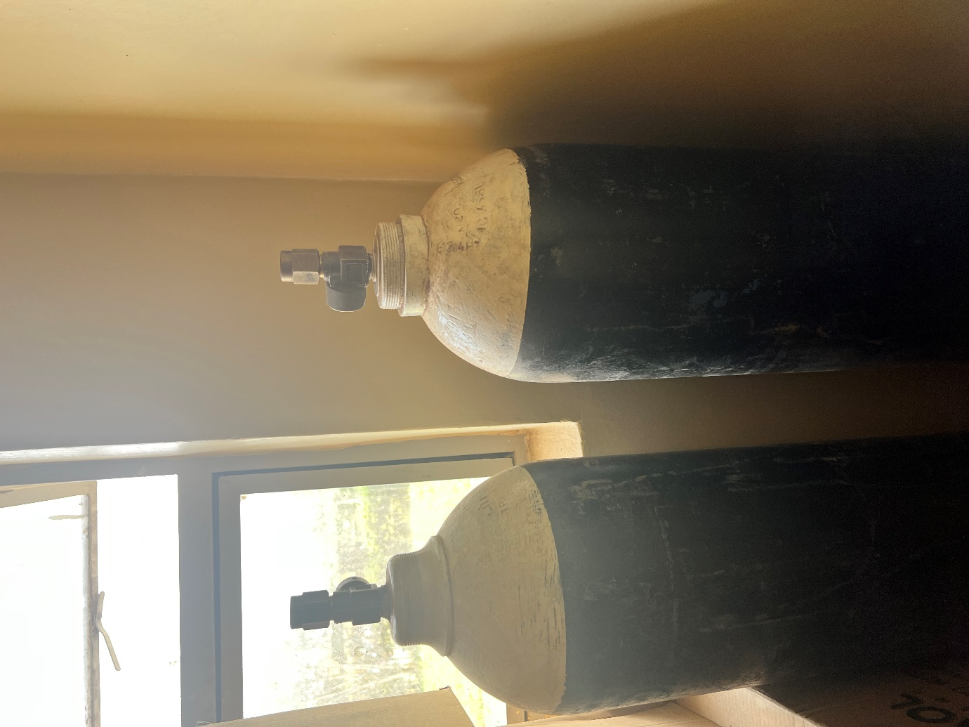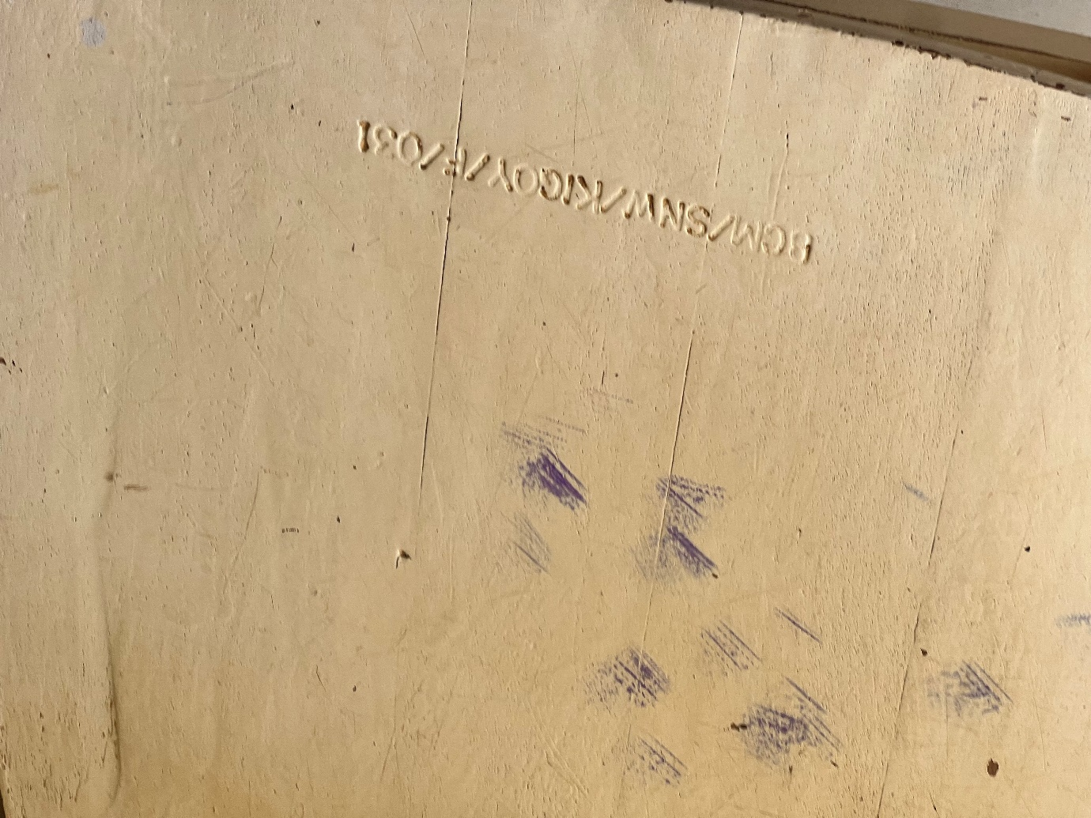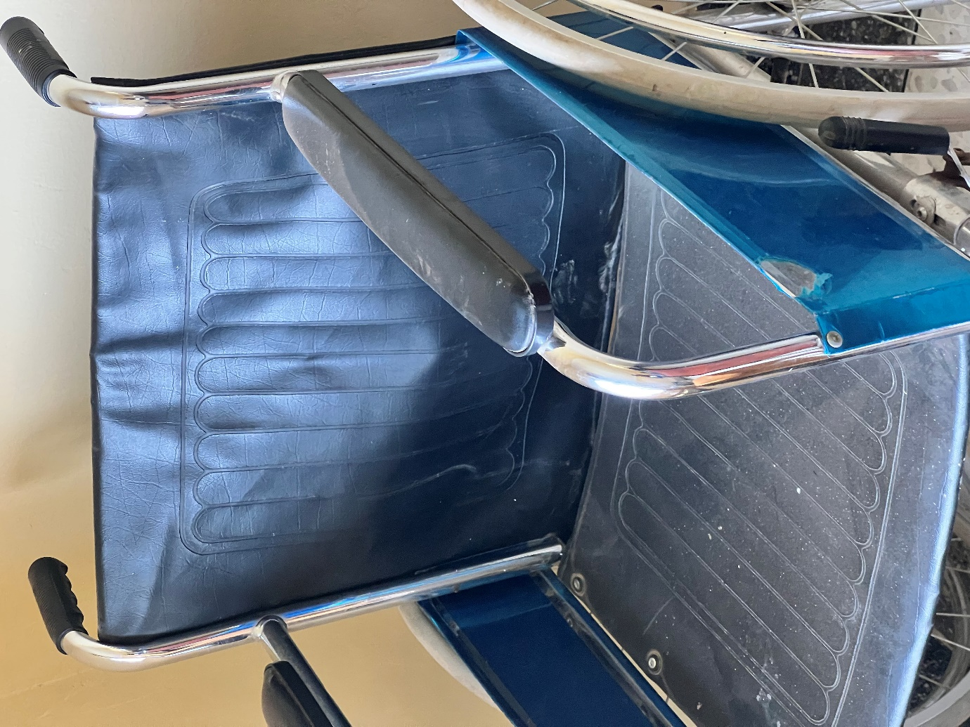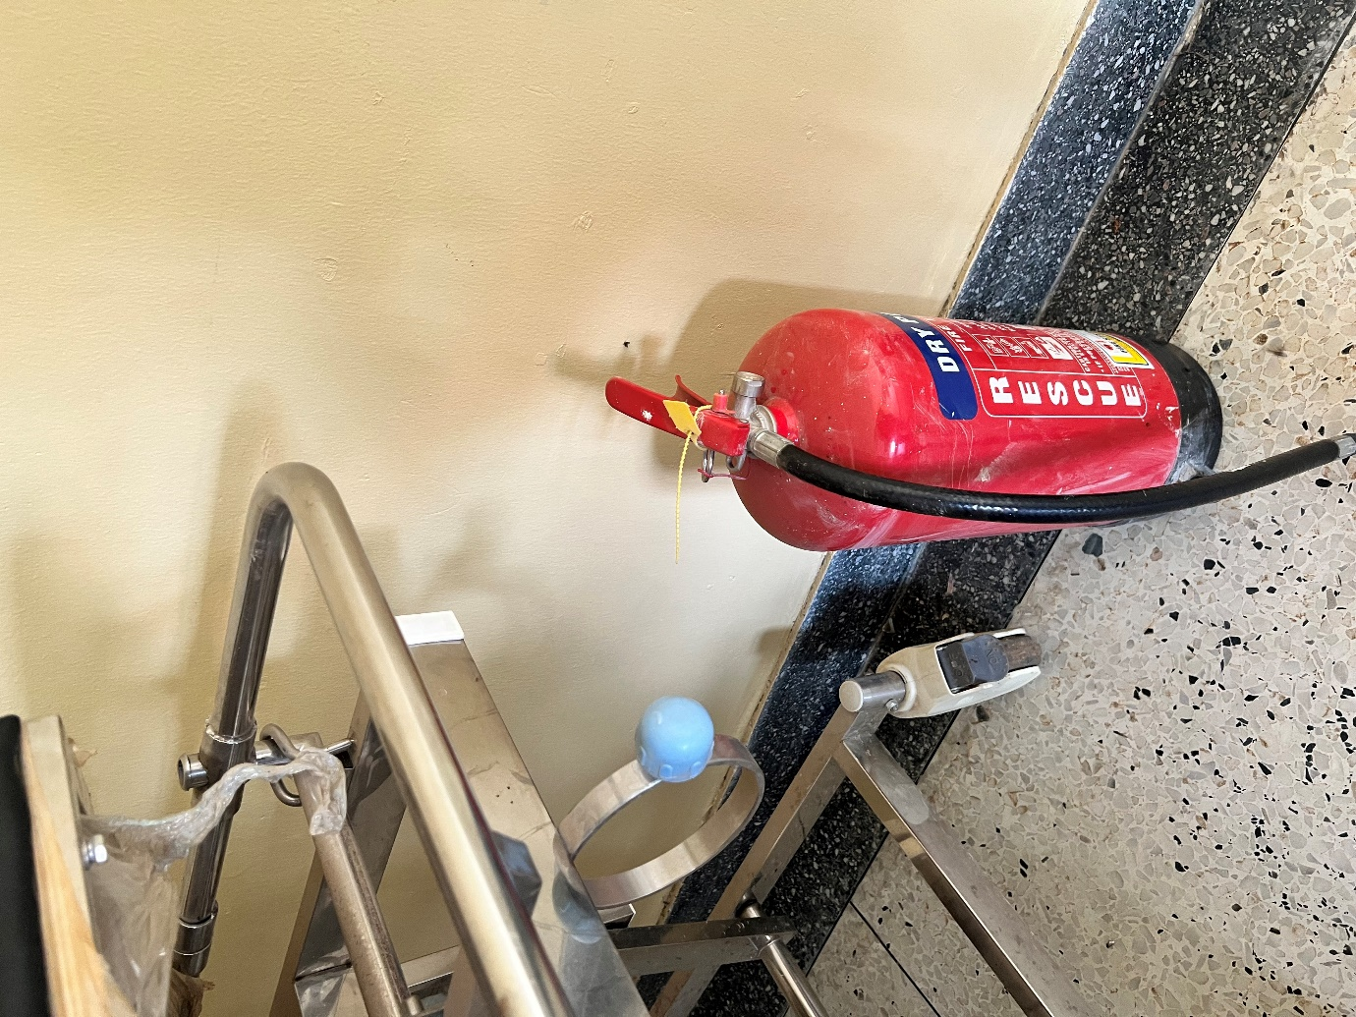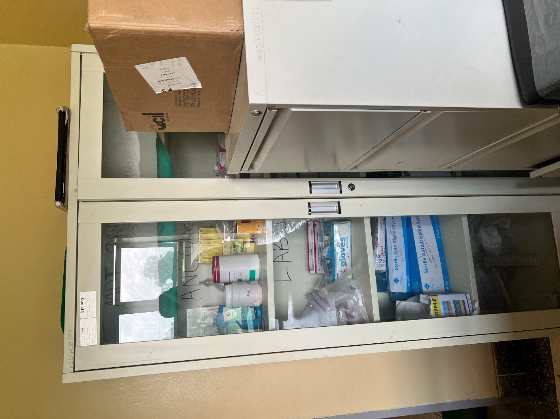m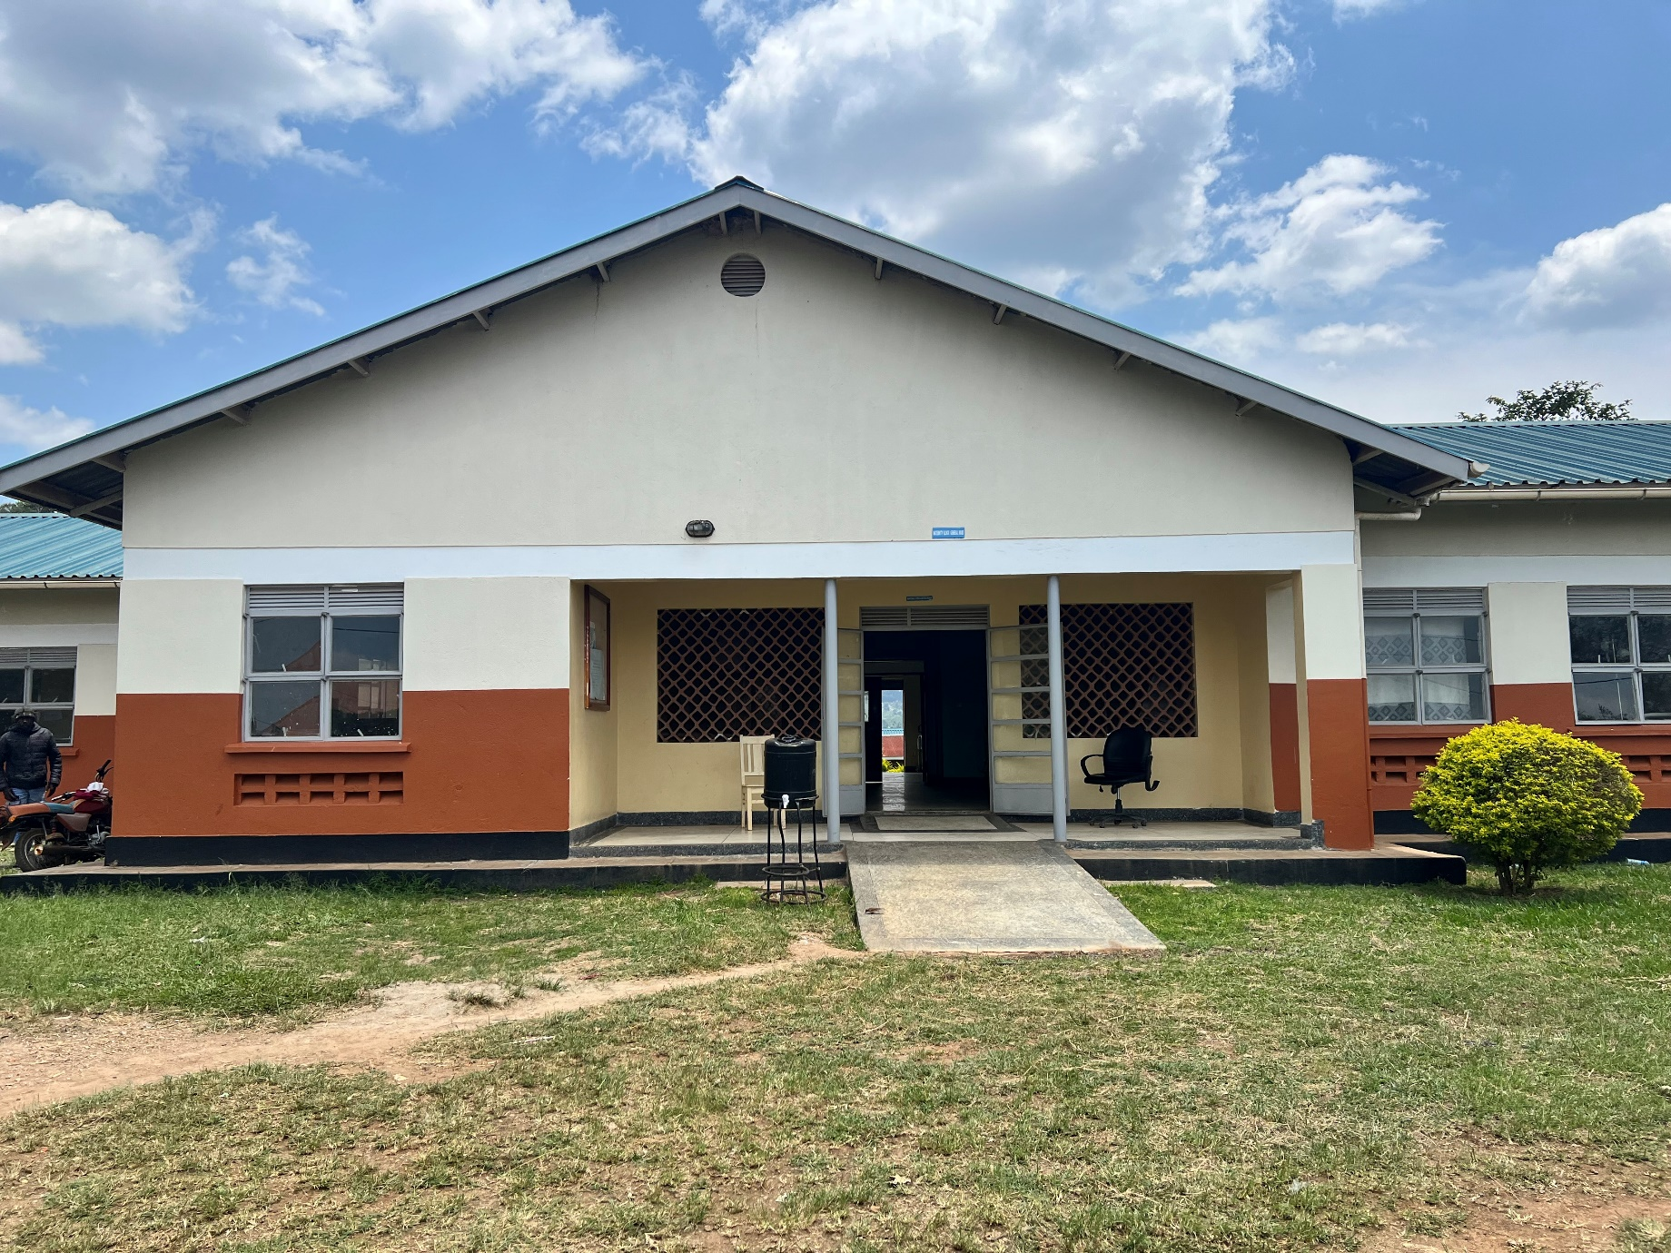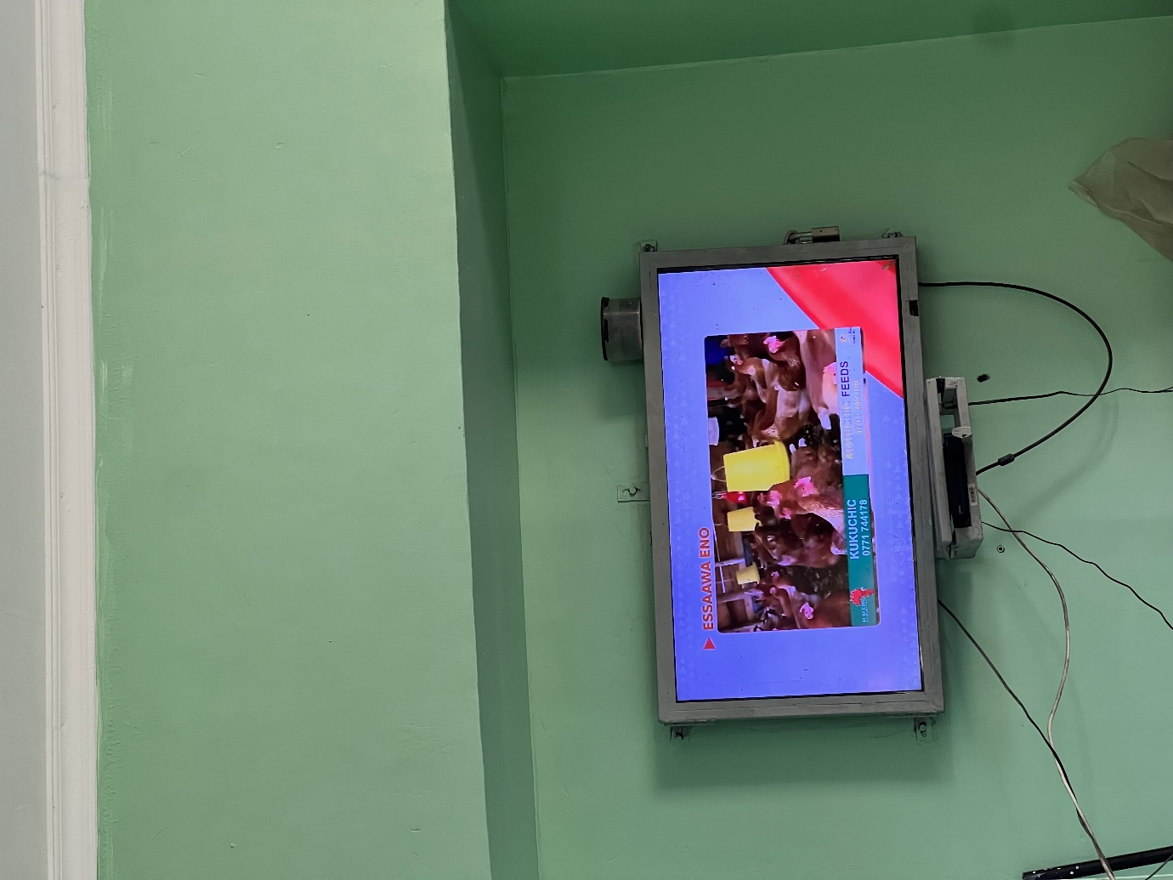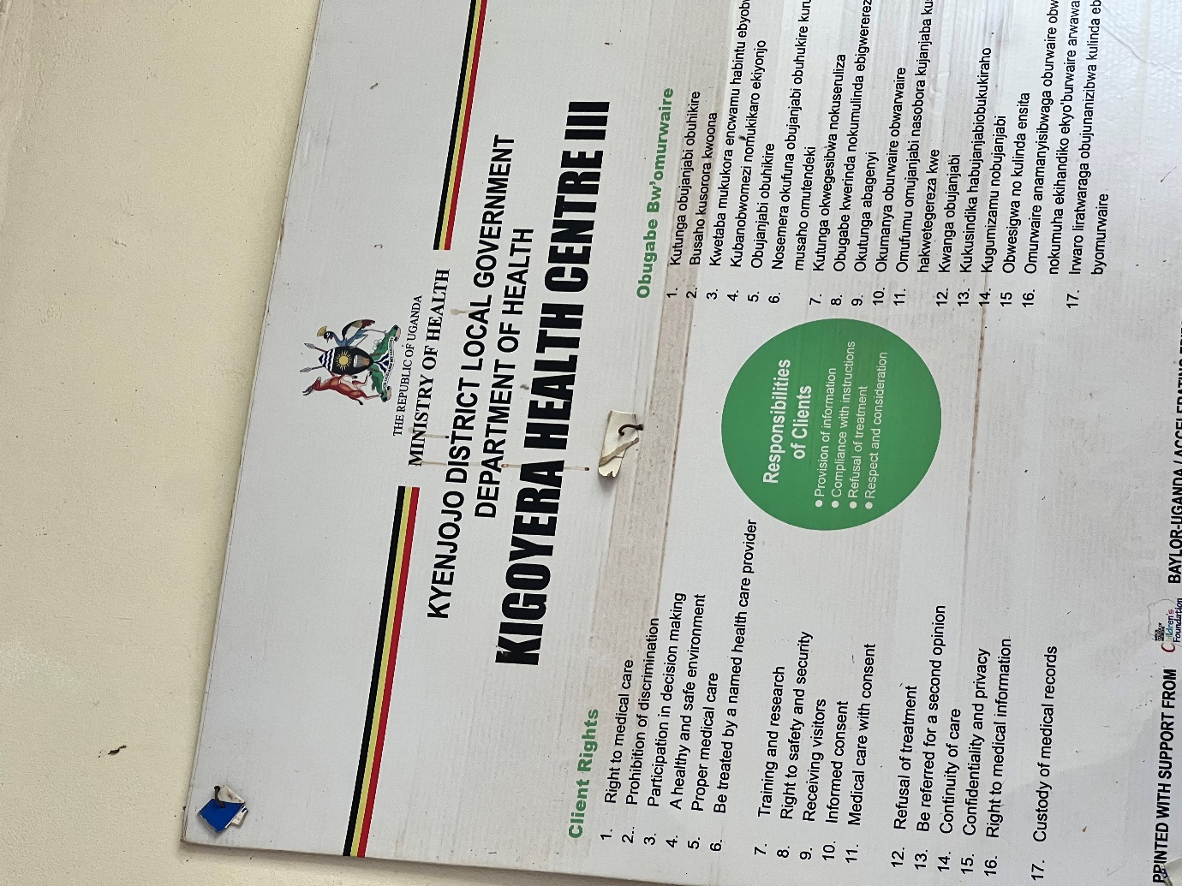
Oxygen gas cylinders with chairs
Wheel chair and fire extinguisher
Cupboard

Filing cabinet

Maternity ward
Television
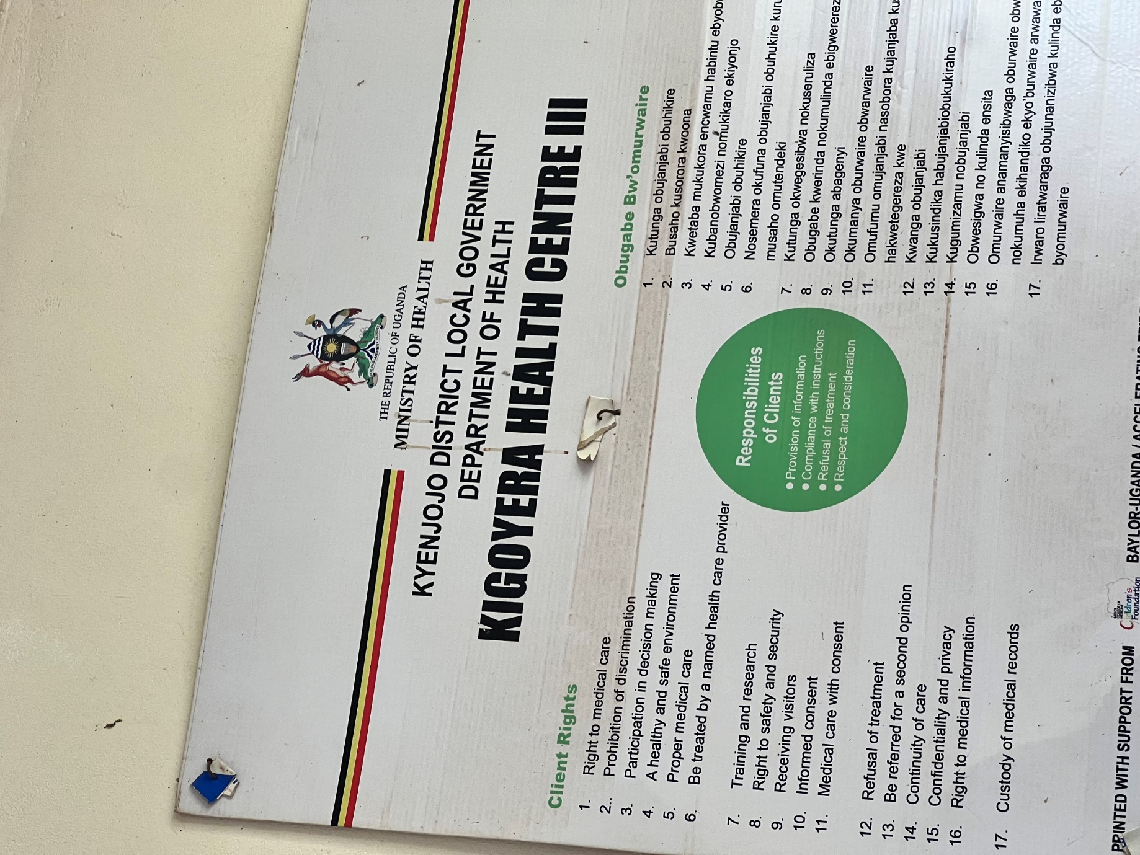

SCHOOL VERIFICATION CHECKLIST

SCHOOL INTERVIEW/DISCUSSION GUIDE

Name of school: KYEMBOGO SEED SECONDARY SECONDARY SCHOOL

1a | Does the Facility have a record of all assets provided under UgIFT.  (Obtain a record and verify if it has the costs and numbers supplied | yes
1b | If Not ask how many were supplied and when.

2 | How does this facility Maintain (repair/service/replace) the assets provided under Ugift

The school has a budget in their financial year school budget that was allocated to only maintaining and repairing the UGIFT assets in case of any damage.

3 | Does the facility take regular record about functionality/ or breakdown of the assets provided?  Nonfunctional/ working, and reasons for non-functionality. | Not fully

Out of 28 computers that were given to the school, 18 of them were stolen and there was no proper documentation from the police and other responsible authorities to prove the thefty claim.

4 | How has the UgIFT support helped in service delivery in the area, any issues, challenges and any recommendations for better program implementation.

The headmaster appreciated the UGIFT program for promoting sciences and computer subjects following the construction of the
Laboratory and computer teaching facility in their community.

He said that the 18 out of 28 computers that were given to them by the program were stolen.

He recommended that there should be security measures to ensure the safety of these assets like CCTvs

PROCEED TO VERIFICATION AFTER THIS DISCUSSION

SCHOOL FURNITURE
(School Desks, Office chairs, Laboratory stools, Book shelves)

Name of SCHOOL KYEMBOGO SEED SECONDARY SCHOOL

Equipment/ Item | Department | Asset Number | Item  Description | Life in Months | Tag Number ( engrave no.) | Date Of Pur | Date Placed In Service | Recoverable cost | Cost | Acc Dep Cost | Net Book Value | Ytd Deprn | Equipment status | Remarks
School desks | Education |  | Wooden varnished desks |  | KYESS  KYESS  KYESS  KYESS | l |  |  |  |  |  |  | Functioning and in good shape | The school received 120 engraved desks, all in good shape
School chairs | Education |  | Cushioned chairs |  | KYESS  KYESS  KYESS  KYESS |  |  |  |  |  |  |  | Functional. | The school received 20 chairs in good shape and already in use.
School chairs | Education |  | Non-cushioned chairs |  | KYESS  KYESS  KYESS  KYESS |  |  |  |  |  |  |  | Functional | Received 267 well engraved and good in shape chairs.
School stools | Education |  | Well varnished stools |  | KYESS  KYESS  KYESS |  |  |  |  |  |  |  | Functional | The school received 265 already engraved stools ready to use.
Lockable shelves | Education |  | Rectangular well varnished wooden with shelves inside |  | KYESS  KYESS  KYESS  KYESS |  |  |  |  |  |  |  | Functional | The school received a total of 26 lockable shelves in good shape
School tables | Education |  | Well varnished wooden tables |  | KYESS  KYESS  KYESS  KYESS |  |  |  |  |  |  |  | Functional | Received a total of 81 engraved tables in good shape and already in use

ICT ITEMS TO VERIFY
(Desktop Computer, Server Processor, Network Switch 24 Port, Multipurpose Printer, UPS, Projector, Air Conditioners, Server, CCTV Camera)

Name of LG KYENJONJO

Name of SCHOOL KYEMBOGO SEED SECONDARY SCHOOL

Equipment/ Item | Department | Asset Number | Item  Description | Life in Months | Tag Number ( engrave no.) | Date Of Pur | Date Placed In Service | Recoverable cost | Cost | Acc Dep Cost | Net Book Value | Ytd Deprn | Equipment status | Remarks
Computers and accessories | Education |  | Fully eguipped del  computers |  | Not engraved |  |  |  |  |  |  |  | Functional | Received fully equipped 28 computers
Multi purpose printer | Education |  | Fully equipped printer |  | KYESS |  |  |  |  |  |  |  | Functional | Received a fully functioning printer.

BUILDINGS TO VERIFY
(Non- Residential and Residential, Kitchen, Toilets/Pit latrine Water tanks, Fences etc.)

Name of LG KYENJOJO
Name of SCHOOL KYEMBOGO SEED SECONDARY SCHOOL

Equipment/ Item | Department | Asset Number | Item  Description | Life in Months | Tag Number ( engrave no.) | Date Of Pur | Date Placed In Service | Recoverable cost | Cost | Acc Dep Cost | Net Book Value | Ytd Deprn | Equipment status | Remarks
Borehole | education |  | A well built borehole to ease water supply |  | KYESS |  |  |  |  |  |  |  | functional | In good shape and in use
Staff toilets | Education |  | Well built 1 block of 2 stances and a bathroom |  |  |  |  |  |  |  |  |  | functional | Fully functioning and in good shape
Staff quarters | Education |  | 3 blocks of two units of two rooms |  |  |  |  |  |  |  |  |  | Functioning | Construction still in progress
Student toilets | Education |  | 2 blocks of respective gender boys and girls of 5 stances with a dressing room on the girls’ block |  |  |  |  |  |  |  |  |  | Fully functioning | Good shape and already in use
Kitchen | Education |  | 2 blocks of 2 rooms |  |  |  |  |  |  |  |  |  | Functional | In use
Student Laboratory | Education |  | I block of 2 rooms |  |  |  |  |  |  |  |  |  | Functional l | In use
Computer lab | education |  | I block of 2 rooms with a library |  |  |  |  |  |  |  |  |  | Functional | In use
Multi purpose hall | Education |  | I block of 2 entrances |  |  |  |  |  |  |  |  |  | Functional | In use
Staff quarters toilets | Education |  | 2 blocks of two stances and a bathroom |  |  |  |  |  |  |  |  |  | Functional | In use
Staff quarters kitchen | Education |  | 3 blocks of 2 units |  |  |  |  |  |  |  |  |  | Functional | In use
classrooms | Education |  | 3 blocks of two classes |  |  |  |  |  |  |  |  |  | Functional | In use

